**Project 2**

<Blackjack>

Modified

CSC - 5 - 46090

Allende, Katelyn

7/31/2015

Table of Contents

**Description 1**

**Summary2**

**Objective 2**

**Implementation 2**

**Sample I/O 3**

**Variables5**

**Cross Reference 6**

**Pseudo-Code 8**

**Flowchart 12**

**Program16**

**References 24**

Description

Title: Blackjack Game

Blackjack is a popular casino game that is now played all around the world. In the game the aim of the player is to achieve a hand whose points total nearer to 21 than the dealer's hand without exceeding 21.

Equipment:

The game of Blackjack is played with a traditional 52-card deck minus the jokers. Each of these cards are valued at the following:

- An Ace can equal either 1 or 11, whichever makes a better hand.

- Cards 2 from 9 are valued at their face value.

- The 10, Jack, Queen, and King are all valued at 10.

Rules of the Game:

At the start of the game each player starts with two cards. One of the dealer's cards is hidden throughout the entire game until the end. Upon looking at their first two cards the player has two choices. The player can either 'Hit' and receive an additional card or 'Stay' to hold their total and terminate their turn. The dealer must hit until their cards total 17 or higher.

If the player's hand exceeds 21 they bust and the dealer automatically wins no matter the score of their hand. If the player's hand is closer to 21 without exceeding that amount they have beat the dealer. Finally, a blackjack is a total of 21 in their first two cards, which results in an automatic win.

Betting System:

-If the player wins, their winnings are double the bet they made for that hand.

-If the player losses, they lose the amount they bet for that hand.

-If the hand ends in a tie, the player gains nothing, but gets the amount of money they bet for that hand back in their pot.

Summary

Project Size: 423 lines

Number of Variables: 36

Number of Methods: 37

* This program is a modified game and took approximately a week.
* Modification of the program made the game more accurate to the real game (bet system).
* The difficulty of the project was moderate and made easier after learning how to apply functions.
* 31 concepts were utilized, however there were 2 constructs I was unable to incorporate.

1. Sorting/Searching Arrays

- Even though I know how to sort arrays, for this game of Blackjack it did not make logical sense for me to add it in I thought. I had the idea to have the player's hand sorted after each hit, but that would just confuse the player on which new card they received.

1. 2D Arrays

-Unsure how to implement these into my program. Guess the game of Battleship would have better for that!

* It was challenging to program my first game, but rewarding after it ran successfully.

Objective

To program a game using the constructs learned in class. The program allows the player to play the game of Blackjack against the dealer (computer) with the incorporation of bets.

Implementation

I pulled from a file to output the welcome heading. Used the random number generator to shuffle the array with the deck of cards. Used multiple functions to shuffle deck, print cards and hands, score hand, deliver next card, print final score and hand as well as the player's updated pot amount. In the main it allows the player to input their name, starting pot amount, bet amount, whether or not they would like to hit or stay and if they would like to continue playing. A combination of if-else statements, loops and calling of functions allows the program to output the winner based on their score. Throughout the main there are also various input validations to ensure the game is being played correctly.

Sample I/O

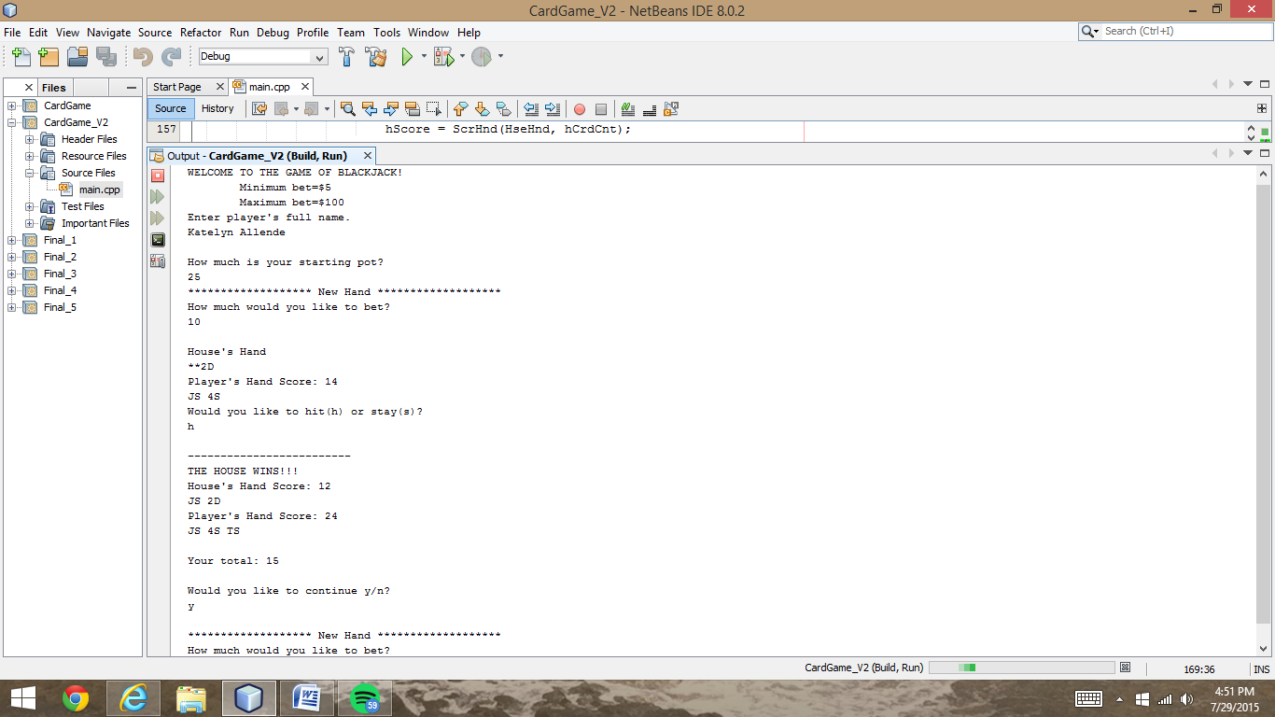

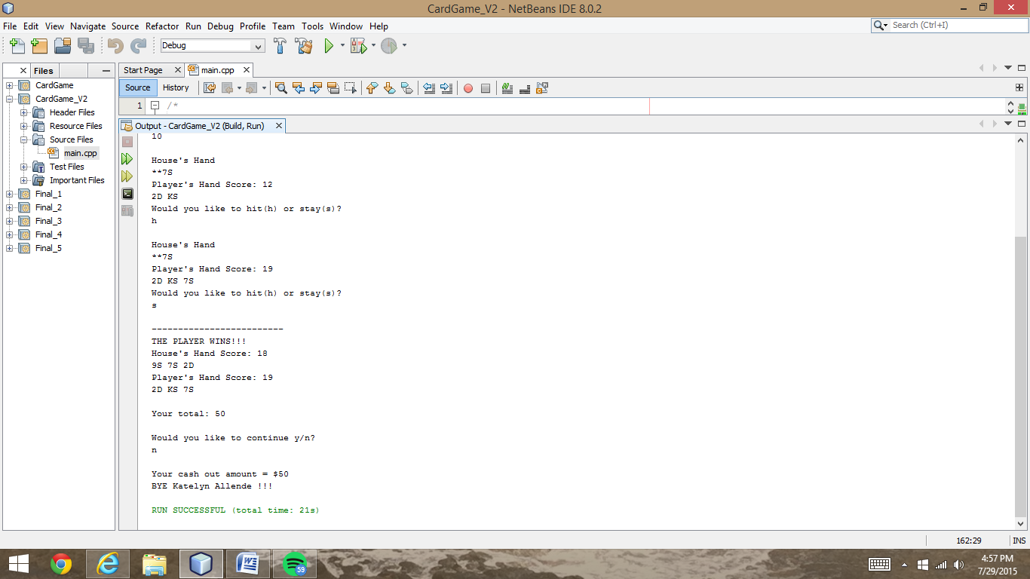

Shows a full hand and the ability to play again

Player no longer wishes to play. Outputs cash out amount and says bye.

Sample I/O cont.

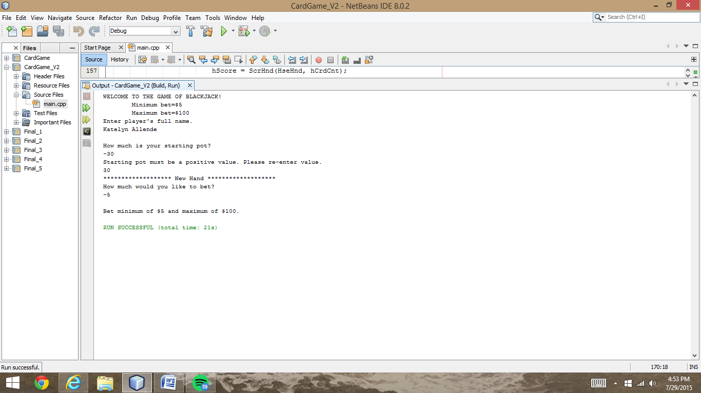

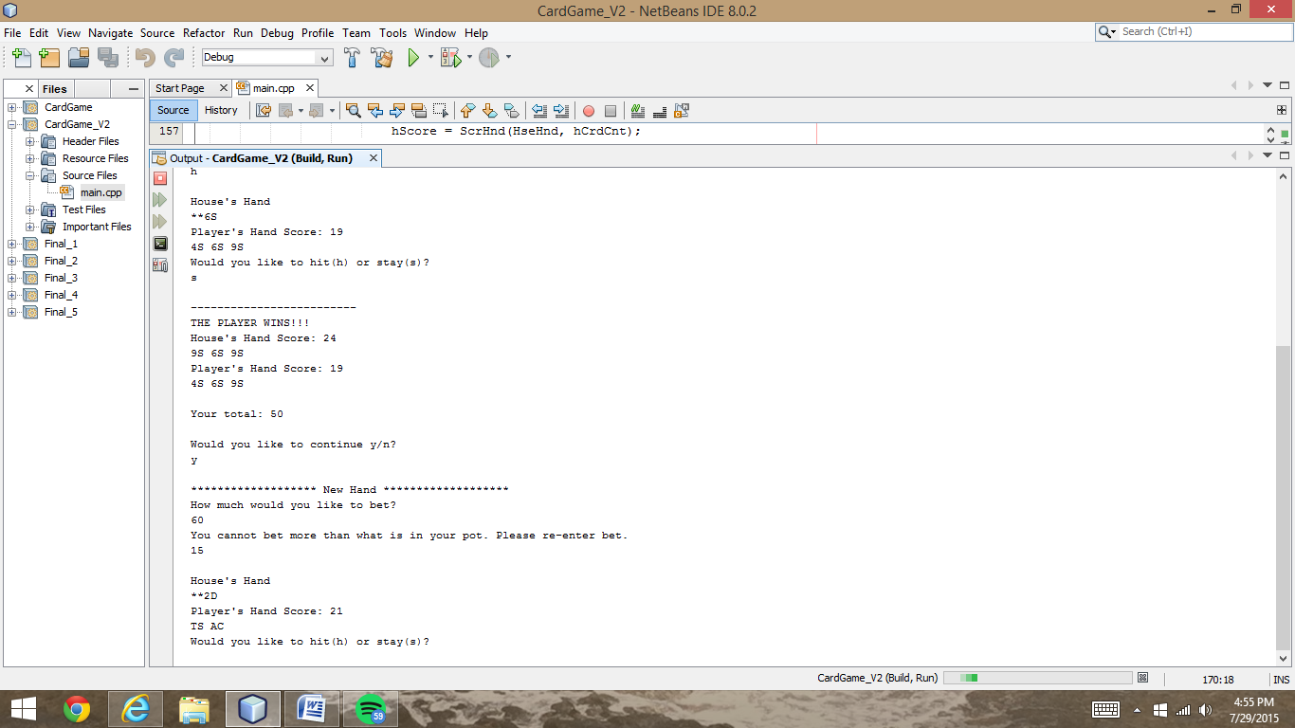

Input Validation:

Bet Amount exceeds Pot Amount

Input Validation:

Bet Minimum/Maximum

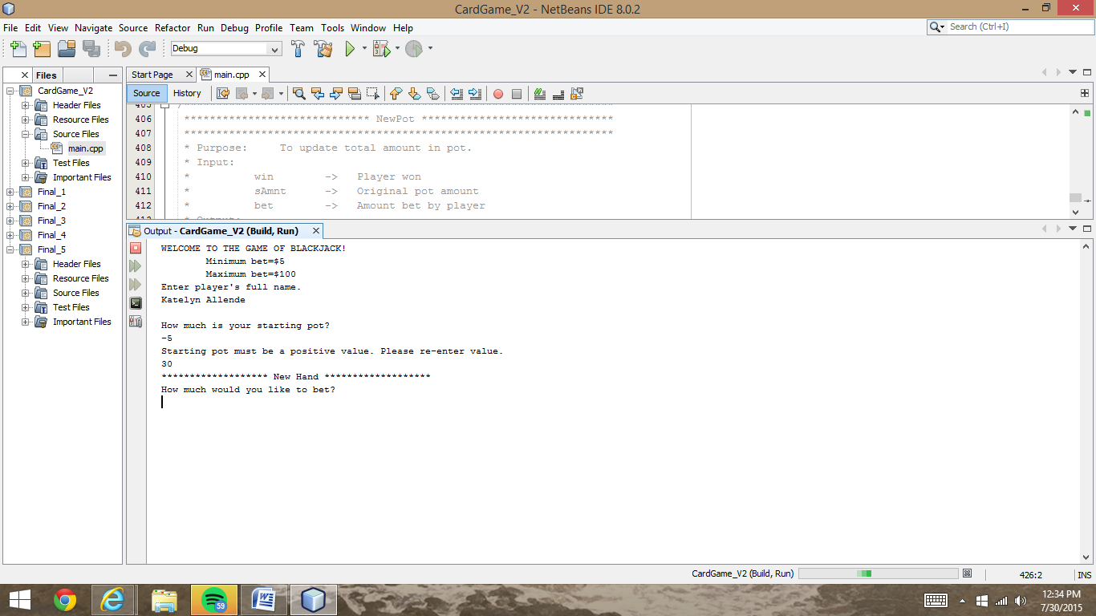

Input Validation:

Starting pot must be a positive value.

Variables

|  |  |  |  |
| --- | --- | --- | --- |
| Type | Variable Name | Description | |
| bool | CrdsDlt[52] | Deck of Cards | |
| int | hCrdCnt, pCrdCnt | House / Player Card Count | |
| int | *HseHnd/PlyrHnd=new int [12] | Array of House/ Player Hand | |
| bool | doAgain | Loop decision to play again or not | |
| char | pChoice | Choice to Hit or Stay | |
| bool | pHits | Player Hits | |
| int | pScore, hScore | Player's / House's Score | |
| bool | hBusts | House Bust | |
| char | response | Decision to continue or not | |
| const int | hCnt, pCnt | House/ Player Count | |
| int | h | Hand | |
| const int | t | Card Count | |
| int | AceCnt | Ace Count | |
| int | Score | Score of Hand | |
| int | newCrd, newCard | New Card | |
| int | iRank | Rank of card | |
| int | r | Loop to score/print hand | |
| bool | d | Decision for next card or not | |
| const int | iNxtCrd | Next Card | |
| const int | cRank, cSuit | Card Rank/ Suit | |
| char | name | Player's first/ last name | |
| int | Pot | Pot Amount | |
| int | betAmnt | Bet Amount | |
| string | line | Welcome Line | |
| int | p | Card | |
| bool | win | Player won hand | |
| float | sAmnt | Original pot amount | |
| float | bet | Amount bet by player | |
| float | newPot | Updated Pot Amount | |
| int | i | | Loop to shuffle cards |

Cross Reference

|  |  |  |
| --- | --- | --- |
| Syntax/Keywords | | Location |
| System Libraries/ Math Library | | iostream, cstdlib, ctime, string, fstream |
| void (functions) | | void shuffle, PrntCrd, PrntHnd, PrntSaH |
| int (functions) | | int NxtCard, ScrHnd |
| float (function) | | float NewPot |
| pointers | | Functions: shuffle (CrdsDlt), PrntHnd (h), NxtCard (CrdsDlt), HseHnd, PlyrHnd |
| Pass by reference | | Functions: PrntSaH (hCnt, pCnt) |
| Arrays / Dynamic | | Functions: shuffle (CrdsDlt), ScrHnd (h)  Dynamic: PrntSaH (HseHnd, PlyrHnd) |
| string | | line |
| switch | | pChoice |
| ifstream (file input) | | inFile |
| Boolean | | CrdsDlt, doAgain, hBusts, d, win |
| srand | | (time(0)) |
| rand () | | newCard |
| do-while | | doAgain, NxtCard (d), pHits && pScore < 22 |
| while | | (pHits&&pScore<22), (hScore<17), (AceCnt>0&&Score<12), getline (inFile,line), Pot<0, betAmnt>Pot |
| if-else | | pChoice, pScore, hBusts, iRank, cRank, cSuit, Pot>0, betAmnt>=5 && betAmnt<=100, response |
| if | | inFile.is_open, !CrdsDlt[newCard] |
| for | | Functions: ScrHnd (r), PrntHnd (r), shuffle (i) |
| true | | pHits, doAgain, d, NewPot |
| false | | pHits, doAgain, d, CrdDlt[i], NewPot |
| Relational and logical operators  (==,>,<,&&,!,||) | | Numerous locations throughout code |
| Arithmetic operators  (+, - , = , *) | | Numerous locations throughout code |
| Increment operator (++) | | pCrdCnt, hCrdCnt, r, AceCnt, Score, i |
| Decrement operator (--) | | AceCnt |
| % | | iRank, newCard, cRank, cSuit |
| Variable types | Bool, int, const int, char, float, | |
| Arithmetic Operators Precedence | Function NewPot (newPot=sAmnt+(bet*2)) | |
| Conditional Operator | Function NewPot (win)?(newPot=sAmnt+(bet*2)):(newPot=sAmnt-bet); | |
| Nesting Loops | Numerous locations throughout code | |
| Structures | input | |
| void | Functions: PrntSaH, PrntHnd, PrntCrd, shuffle | |
| return | 0  Functions: ScrHnd (Score), NxtCard (newCard), NewPot(newPot) | |

ALSO...

* Mathematical Statements
* Pass by Value

Pseudo-Code

System Libraries

Structure input

Function Prototypes

Declare Variables

Welcome/Rules Heading pulled in from a file (instrct.dat)

Using structure output player's full name

Starting Pot Amount

While (Pot is less than 0)

Starting pot must be a positive value. Please re-enter value.

Do

If (Pot is greater than 0)

Set the random number seed

Shuffle the cards

Deal two cards to each player

Heading for a new hand

Bet Amount

While (betAmnt is greater than Pot)

You cannot bet more than what is in your pot. Please re-enter bet.

If (betAmnt is greater than or equal to 5 and betAmnt is less than or equal to 100)

Do

Display first two cards

Ask player if they would like to hit or stay

If (pChoice equals equals 'h' or 's')

Switch Statement (pChoice)

case 'h':

PlyrHnd[pCrdCnt] equals pull from NxtCard function

Increment operator for pCrdCnt

case 's':

Hit equals false

default:

"Invalid input. Try Again."

Else

"Invalid input. Try Again."

Update score, check for bust, and see who won

pScore equals pull from ScrHnd function (PlyrHnd , pCrdCnt)

While (pHits and pScore is less and 22)

If pScore is greater than 21

"THE HOUSE WINS!!!"

Pull from PrntSaH function

Pot equals NewPot function (false, Pot, betAmnt)

Else if pScore equals equals 21

"THE PLAYER WINS!!!"

Pull from PrntSaH function

Pot equals NewPot function (true, Pot, betAmnt)

Else

hScore equals pull from ScrHnd function (HseHnd, hCrdCnt)

While hScore is less than 17

HseHnd [hCrdCnt] equals pull from NxtCard function

Increment CrdCnt

hScore equals pull ScrHnd function (HseHnd, hCrdCnt)

hBusts equals hScore is less than 21

If hBusts

"THE PLAYER WINS!!!"

Pull from PrntSaH function

Pot equals NewPot function (true, Pot, betAmnt)

Else

If pScore equals equals hScore

"TIE!!!"

Pull from PrntSaH function

Pot

Else if pScore is greater than hScore

"THE PLAYER WINS!!!"

Pull from PrntSaH function

Pot equals NewPot function (true, Pot, betAmnt)

Else

"THE HOUSE WINS!!!"

Pull from PrntSaH function

Pot equals NewPot function (false, Pot, betAmnt)

Else

Bet minimum of $5 and maximum of $100.

Else

You have no more money! GAME OVER!

Bye name (from structure) !!!

Prompt if they would like to continue

If response equals equals 'y'

doAgain equals true

Else

doAgain equals false

Your cash out amount = $ Pot

BYE name (from structure)!!!

While (doAgain)

delete HseHnd/PlyrHnd

Return

Void PrntSaH function

ScrHnd function for both the Hse/Plyr Hnd and h/p Cnt

Int ScrHnd function

Declare Variables

For

Increment r if r is less and t

newCrd equals h[r]

iRank equals newCrd mod 13

If iRank equals equals 0

Increment AceCnt and Score

Else if iRank is less than 9

Score equals score plus (iRank plus 1)

Else

Score equals score plus 10

While AceCnt is greater than 0 and score is less than 12

Decrement AceCnt

Score equals score plus 10

Return Score

Int NxtCard function

Declare Variables

Do

newCard equals random number seed mod 52

If CrdsDlt not [newCard]

d equals false

While (d)

Return newCard

Void PrntHnd

For

Increment r if r is less than t

iNxtCrd= h[r]

Pull from PrntCrd function (iNxtCrd)

Void PrntCrd

Declare Variables

Print the rank of the card

If cRank equals equals 0

Output 'A'

Else if cRank is less than 9

cRank plus 1

Else if cRank equals equals 9

Output 'T'

Else if cRank equals equals 10

Output 'J'

Else if cRank equals equals 11

Output 'Q'

Else

Output 'K'

Print the suit of the card

If cSuit equals equals 0

Output 'C'

Else if cSuit equals equals 1

Output 'D'

Else if cSuit equals equals 2

Output 'H'

Else

Output 'S'

Void shuffle

For

Increment i if i is less than 52

CrdsDlt[i] equals false

Float NewPot

Declare Variables

If (win)

newPot equals sAmnt plus (bet times 2)

return newPot

Else

newPot equals sAmnt minus bet

return newPot

Flowchart (main)

**\*flowcharts additionally in Project folder**

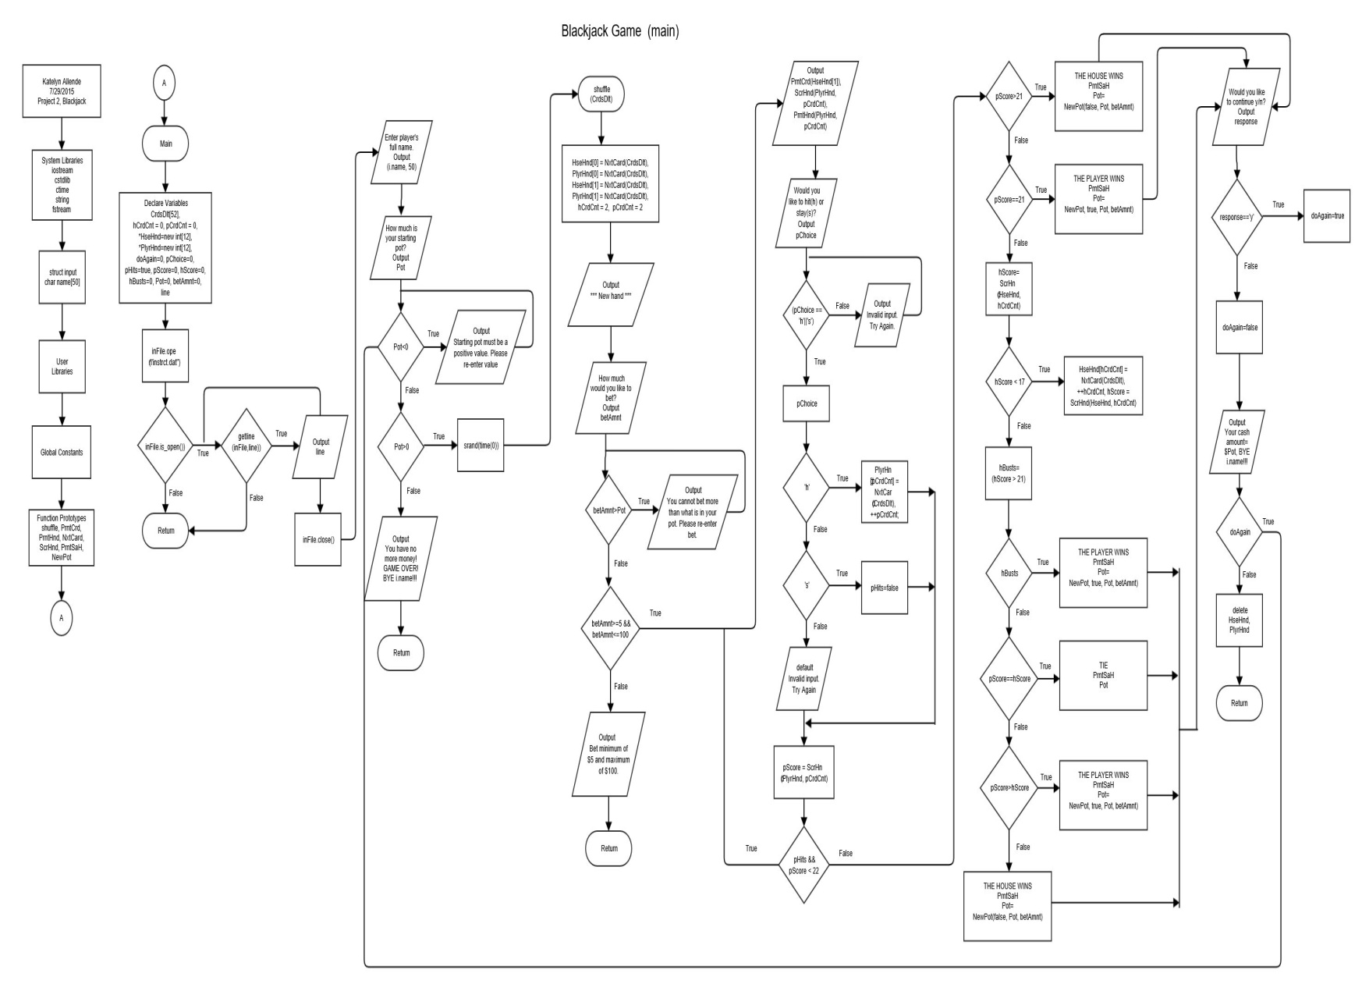

Flowchart (functions pt. 1)

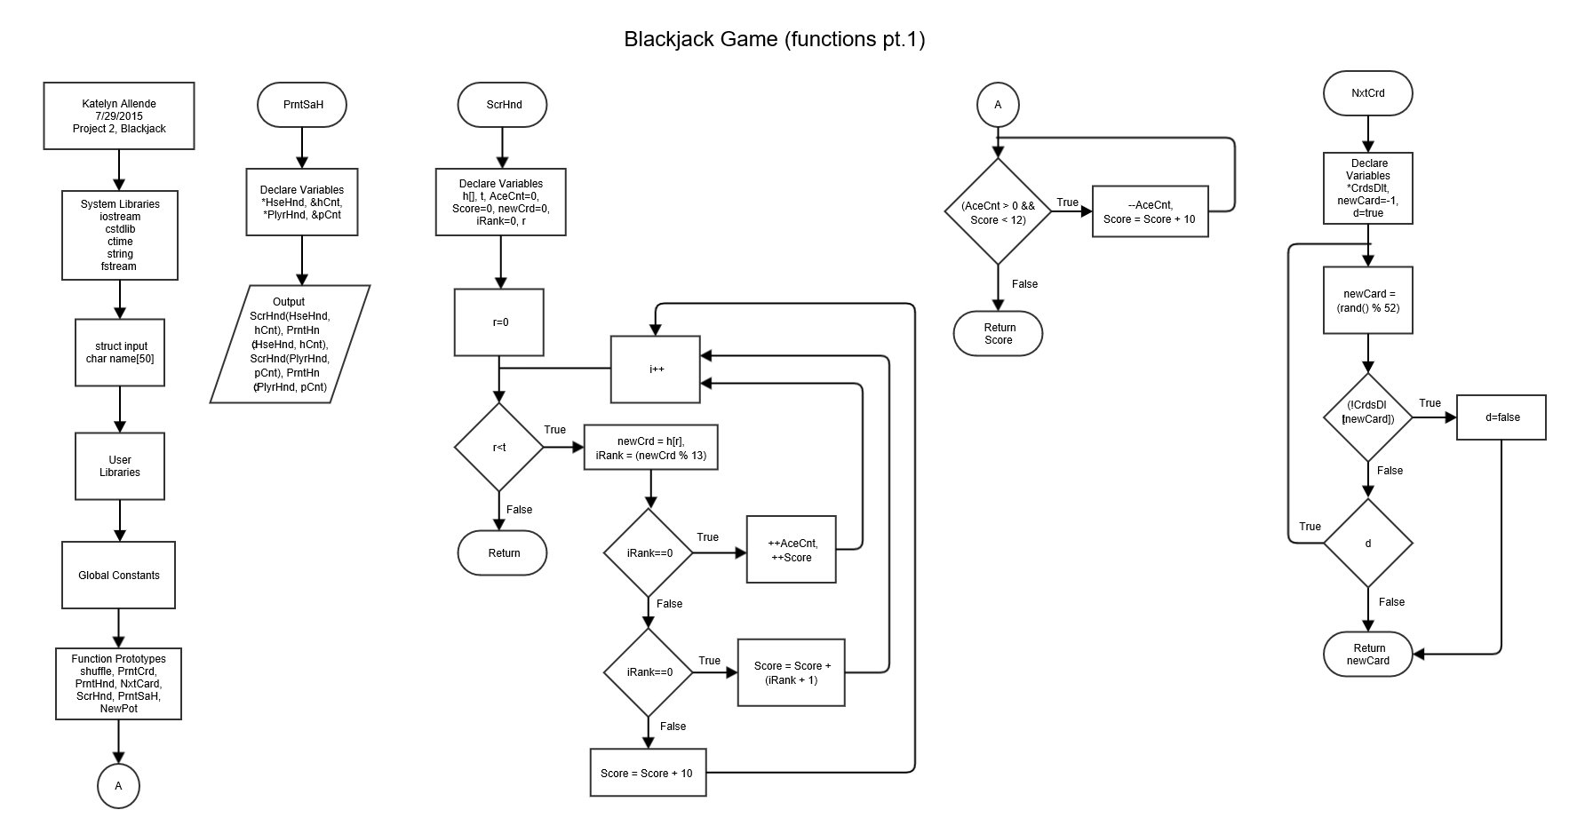

Flowchart (functions pt. 2)

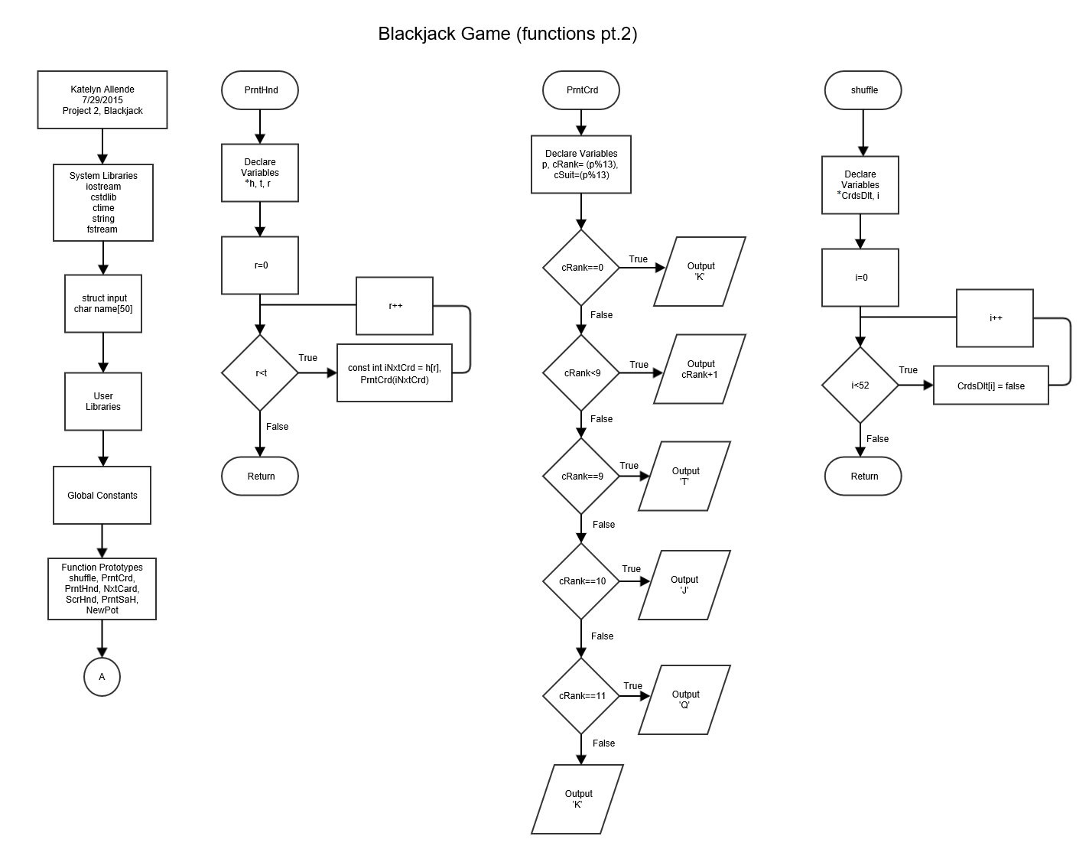

Flowchart (functions pt. 3)

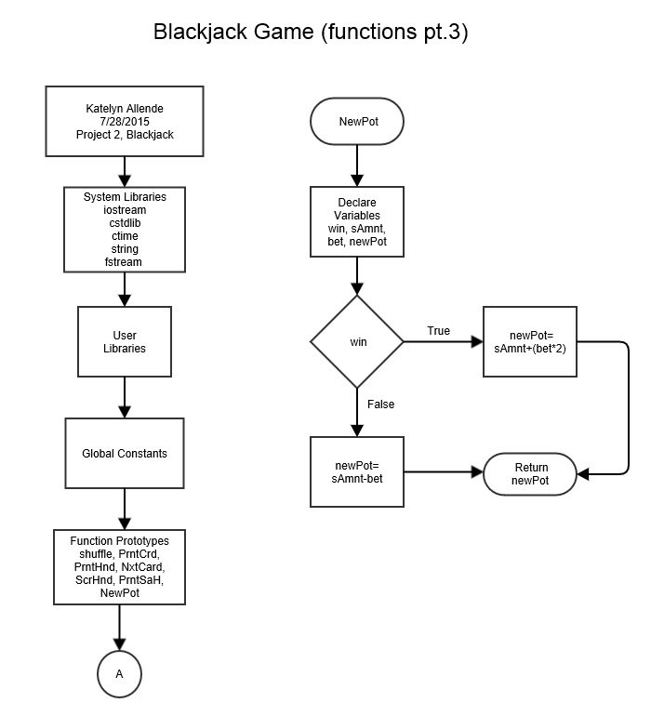

Program

/*

* File: main.cpp

* Author: Katelyn Allende

* Created on July 26, 2015, 9:50 AM

* Purpose: Project 2 - Create a game -

* Blackjack (modified)

*/

//System Libraries

#include <iostream>

#include <cstdlib>

#include <ctime>

#include <string>

#include <fstream>

using namespace std;

struct input {

char name[50];

};

//User Libraries

//Global Constants

//Function Prototypes

void shuffle(bool *);

void PrntCrd(int);

void PrntHnd(int *, const int);

int NxtCard(bool *);

int ScrHnd(int [], const int);

void PrntSaH(int [], const int &, int [], const int &);

float NewPot (bool, float, float);

//Execution Begins Here!

int main(int argc, char** argv) {

//Declare Variables

bool CrdsDlt[52]; //Deck of Cards

int hCrdCnt=0, pCrdCnt=0; //House & Player Card Count

int*HseHnd=new int[12]; //Dynamic Array of House Hand

int*PlyrHnd=new int[12]; //Dynamic Array of Player Hand

bool doAgain=0; //Decision to play again or not

char pChoice=0; //Choice to Hit or Stay

bool pHits=true; //Player Hits

int pScore=0, hScore=0; //Player's & House's Score

bool hBusts=0; //House Bust

int Pot=0; //Pot Amount

int betAmnt=0; //Bet Amount

//Welcome to Blackjack

//Pulling from a file

string line;

ifstream inFile;

inFile.open("instrct.dat");

if (inFile.is_open())

{

while (getline (inFile,line))

{

cout << line << endl;

}

inFile.close();

}

input i; //Structure to output name

i.name;

cout << "Enter player's full name." << endl;

cin.getline(i.name, 50);

//Starting Pot Amount

cout << endl << "How much is your starting pot?" << endl;

cin >> Pot;

//Input Validation

while (Pot<0)

{

cout << "Starting pot must be a positive value. Please re-enter value." << endl;

cin >> Pot;

}

//Loop for each hand

do {

//Pot Amount Validation

if (Pot>0) {

//Set the random number seed

srand(time(0));

//Shuffle the cards

shuffle(CrdsDlt);

//Deal two cards to each player

HseHnd[0]=NxtCard(CrdsDlt);

PlyrHnd[0]=NxtCard(CrdsDlt);

HseHnd[1]=NxtCard(CrdsDlt);

PlyrHnd[1]=NxtCard(CrdsDlt);

hCrdCnt=2;

pCrdCnt=2;

//Heading for a new hand

cout << "******************* New Hand *******************" << endl;

//Bet Amount

cout << "How much would you like to bet?" << endl;

cin >> betAmnt;

//Input Validation

while (betAmnt>Pot)

{

cout << "You cannot bet more than what is in your pot. Please re-enter bet." << endl;

cin >> betAmnt;

}

cout << endl;

//Input Validation

if (betAmnt>=5 && betAmnt<=100) {

//Display first two cards

do {

cout << "House's Hand" << endl;

cout << "**";

PrntCrd(HseHnd[1]);

cout << endl;

cout << "Player's Hand Score: " << ScrHnd(PlyrHnd, pCrdCnt) << endl;

PrntHnd(PlyrHnd, pCrdCnt);

//Ask player if they would like to hit or stay

cout << "Would you like to hit(h) or stay(s)?" << endl;

cin >> pChoice;

if (pChoice == 'h'||'s')

{

switch(pChoice)

{

case 'h':

PlyrHnd[pCrdCnt]=NxtCard(CrdsDlt);

++pCrdCnt;

break;

case 's':

pHits=false;

break;

default:

cout << endl << "Invalid input. Try Again." << endl;

}

} else

{

cout << "Invalid input. Try Again." << endl;

}

cout << endl;

//Update Score, Check for Bust, and See Who Wins

pScore = ScrHnd(PlyrHnd, pCrdCnt);

}while (pHits && pScore<22);

if (pScore>21)

{

cout << "-------------------------" << endl;

cout << "THE HOUSE WINS!!!" << endl;

PrntSaH(HseHnd, hCrdCnt, PlyrHnd, pCrdCnt);

Pot = NewPot(false, Pot, betAmnt);

cout << "Your total: " << Pot << endl;

}else if (pScore==21)

{

cout << "-------------------------" << endl;

cout << "THE PLAYER WINS!!!" << endl;

PrntSaH(HseHnd, hCrdCnt, PlyrHnd, pCrdCnt);

Pot = NewPot(true, Pot, betAmnt);

cout << "Your total: " << Pot << endl;

}else

{

hScore=ScrHnd(HseHnd, hCrdCnt);

while (hScore<17)

{

HseHnd[hCrdCnt]=NxtCard(CrdsDlt);

++hCrdCnt;

hScore=ScrHnd(HseHnd, hCrdCnt);

}

hBusts=(hScore>21);

if (hBusts)

{

cout << "-------------------------" << endl;

cout << "THE PLAYER WINS!!!" << endl;

PrntSaH(HseHnd, hCrdCnt, PlyrHnd, pCrdCnt);

Pot = NewPot(true, Pot, betAmnt);

cout << "Your total: " << Pot << endl;

}else

{

if (pScore==hScore)

{

cout << "-------------------------" << endl;

cout << "TIE!!!" << endl;

PrntSaH(HseHnd, hCrdCnt, PlyrHnd, pCrdCnt);

cout << "Your total: " << Pot << endl;

}else if (pScore > hScore)

{

cout << "-------------------------" << endl;

cout << "THE PLAYER WINS!!!" << endl;

PrntSaH(HseHnd, hCrdCnt, PlyrHnd, pCrdCnt);

Pot = NewPot(true, Pot, betAmnt);

cout << "Your total: " << Pot << endl;

}else

{

cout << "-------------------------" << endl;

cout << "THE HOUSE WINS!!!" << endl;

PrntSaH(HseHnd, hCrdCnt, PlyrHnd, pCrdCnt);

Pot = NewPot(false, Pot, betAmnt);

cout << "Your total: " << Pot << endl;

}

}

}

} else

{

//Input Validation

cout << "Bet minimum of $5 and maximum of $100." << endl;

return 0;

}

} else

{

//No more money

cout << "You have no more money! GAME OVER!" << endl;

cin.ignore();

cout << "BYE " << i.name << "!!!" << endl;

return 0;

}

//Prompt if they would like to continue

cout << endl << "Would you like to continue y/n?" << endl;

char response;

cin >> response;

cout << endl;

if (response=='y') doAgain=true;

else

{

doAgain=false;

cout << "Your cash out amount = $" << Pot << endl;

cin.ignore();

cout << "BYE " << i.name << "!!!" << endl;

}

} while (doAgain);

delete HseHnd;

delete PlyrHnd;

return 0;

}

/*******************************************************************

***************************** PrntSaH *****************************

*******************************************************************

* Purpose: To print the score and hand.

* Input:

* HseHnd -> House Hand

* hCnt -> House Card Count

* PlyrHnd -> Player Hand

* pCnt -> Player Card Count

* Input-Output:

* ScrHnd -> Score Hand for House and Player

* PrntHnd -> Print Hand for House and Player

********************************************************************/

void PrntSaH(int *HseHnd, const int &hCnt, int *PlyrHnd, const int &pCnt) {

//Output each score and the hand

cout << "House's Hand Score: " << ScrHnd(HseHnd, hCnt) << endl;

PrntHnd(HseHnd, hCnt);

cout << "Player's Hand Score: " << ScrHnd(PlyrHnd, pCnt) << endl;

PrntHnd(PlyrHnd, pCnt);

cout << endl;

}

/*******************************************************************

***************************** ScrHnd ******************************

*******************************************************************

* Purpose: To determine the score of the hand.

* Input:

* h -> Hand

* t -> Card Count

* Output:

* score -> Score of hand

********************************************************************/

int ScrHnd(int h[], const int t) {

//Declare Variables

int AceCnt=0; //Ace Count

int Score=0;

int newCrd=0; //New Card

int iRank=0; //Rank of Card

//For-loop to determine score of hand

for (int r=0; r<t; r++)

{

newCrd=h[r];

iRank=(newCrd % 13);

if (iRank==0)

{

++AceCnt;

++Score;

} else if (iRank<9)

{

Score=Score+(iRank + 1);

} else

{

Score=Score+10;

}

}

while (AceCnt>0 && Score<12)

{

--AceCnt;

Score=Score+10;

}

return Score;

}

/*******************************************************************

***************************** NxtCrd ******************************

*******************************************************************

* Purpose: To deal next card(s).

* Input:

* CrdsDlt -> Deck of cards

* Output:

* newCard -> Next card(s)

********************************************************************/

int NxtCard(bool *CrdsDlt) {

//Declare Variable

int newCard=-1;

bool d=true;

//Loop to get next card

do {

newCard=(rand() % 52);

if (!CrdsDlt[newCard])

{

d=false;

}

} while (d);

return newCard;

}

/*******************************************************************

***************************** PrntHnd *****************************

*******************************************************************

* Purpose: To print the card hand.

* Input:

* h -> Hand

* t -> Card Count

* Input-Output:

* On Screen

********************************************************************/

void PrntHnd(int *h, const int t) {

//For-loop to print hand of cards

for (int r=0; r<t; r++)

{

const int iNxtCrd=h[r];

PrntCrd(iNxtCrd);

cout << " ";

}

cout << endl;

}

/*******************************************************************

***************************** PrntCrd *****************************

*******************************************************************

* Purpose: To print the card.

* Input:

* p -> Card

* Input-Output:

* On Screen

********************************************************************/

void PrntCrd(int p) {

//Declare Variables

const int cRank=(p % 13); //Card Rank

const int cSuit=(p % 13); //Card Suit

//Print the rank of the card

if (cRank==0)

{

cout << 'A';

} else if (cRank<9)

{

cout << (cRank+1);

} else if (cRank==9)

{

cout << 'T';

} else if (cRank==10)

{

cout << 'J';

} else if (cRank==11)

{

cout << 'Q';

} else

{

cout << 'K';

}

//Print the suit of the card

if (cSuit==0)

{

cout << 'C';

} else if (cSuit==1)

{

cout << 'D';

} else if (cSuit==2)

{

cout << 'H';

} else

{

cout << 'S';

}

}

/*******************************************************************

***************************** shuffle *****************************

*******************************************************************

* Purpose: To shuffle the deck of cards.

* Input:

* CrdsDlt -> Deck of cards

* Input-Output:

* bool CrdsDlt -> Shuffled cards

********************************************************************/

void shuffle(bool *CrdsDlt) {

//For-loop to shuffle cards

for (int i=0; i<52; i++) {

CrdsDlt[i]=false;

}

}

/*******************************************************************

***************************** NewPot ******************************

*******************************************************************

* Purpose: To update total amount in pot.

* Input:

* win -> Player won

* sAmnt -> Original pot amount

* bet -> Amount bet by player

* Output:

* newPot -> New pot amount for player

********************************************************************/

float NewPot(bool win, float sAmnt, float bet) {

//Declare Variables

float newPot=0.0f; //Updated Pot Amount

//Conditional Operator to calculate for new pot

(win)?(newPot=sAmnt+(bet*2)):(newPot=sAmnt-bet);

return newPot;

}

References

Gaddis, Tony. *Starting out with C++ : From Control Structures through Objects*. Boston: Pearson, 2015. Print.

https://www.blackjackinfo.com/blackjack-rules/blackjack-basics/